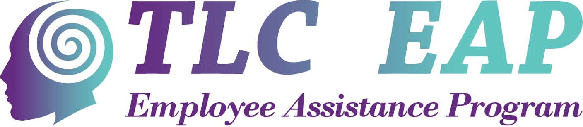

Proposal to provide
Employee Assistance Program (EAP) services

Assisting small business with tailor made programs to give support and confidence to management and staff.

Proposal prepared by:

Mary Mackenzie
Mobile: 0421 231 427
Email: info@TLCEAP.com.au

September 2023

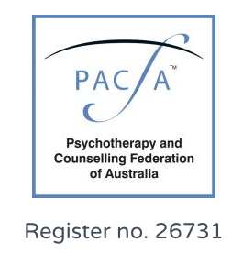

Table of Contents

1. About Mary Mackenzie Counselling and Coaching EAP Services 2
2. Benefits to your organisation 3
3. Services 3
4. How does it work? 4
5. Pricing 4
6. Next steps 4
7. Contacts 4

About TLC EAP Services

Mary Mackenzie
Founder
TLC EAP Services

TLC EAP provides an opportunity for workplaces to champion mental health care by supporting their staff through crisis and personal growth on an as needed basis.
There have been recent changes to workplace psychosocial legislation in Qld.
The legislation requires employers to actively address psychosocial hazards, such as excessive workload, workplace bullying, and poor organizational culture, that can have detrimental effects on employees' mental health. EAP is the recommended way to implement this.

At TLC EAP we will design a program that will enhance the emotional and psychological well-being of your employees and support the resolution of workplace and personal problems that may adversely impact upon work performance and general well-being.

Mary is a qualified and registered counsellor through the Psychotherapists and Counselling Federation of Australia (PACFA). She uses client lead, evidence-based therapies such as Cognitive Behavioural Therapy (CBT), solution focused therapy and positive psychology. Mary’s team of counsellors are all registered counsellors and have a minimum qualification of a Bachelor of Counselling.

Locations
Graceville, Brisbane.
101 Verney Road, Graceville Qld 4075
Plus: Sydney, Melbourne, Ipswich

Online
Appointments also available via Zoom from anywhere in Australia

Benefits to your organisation
The benefits of providing an EAP service, tailored to your business’s needs, include:
- increased work performance and productivity
- reduced absenteeism, conflict and occupational stress
- improved staff morale, employee retention and recruitment
- reduced worker’s compensation
- improved employee satisfaction
- enhanced employer-employee relationships.

Our program also supports your management team by alleviating the burden of responsibility for employee mental wellbeing. In most instances, managers are not aware of their employees’ personal stresses and life events, which may impact their ability to perform their job.

For employees, the interventions provide for the early detection, identification and resolution of workplace and personal problems that are often the cause of reduced productivity in the workplace, including:
- anxiety
- workplace and personal relationships
- depression
- workplace harassment and bullying
- confidence and self-esteem
- illness and bereavement.

Services
TLC EAP can develop an EAP package to support your organisation’s particular needs. Services can be made available to:
- Employees only
- Employees and their immediate family members.

Counselling services offered include:
- Crisis support
- Personal counselling
- Relationship counselling
- Executive coaching
- Financial Coaching
- Tailored workshops.

Sessions are predominately done online, and accessible from anywhere.
All attempts will be made to accommodate face to face session where requested.

How does it work?
One-on-one counselling and coaching sessions are available to employees on an as needed basis, so your business only pays per session booked. There are no retainers or subscription fees for businesses under 50 staff.

Employees are offered blocks of three to six one-hour sessions per 12-month period. Sessions can be booked voluntarily by employees and or recommended by management.

All voluntary counselling is anonymous, and all information provided to the counsellor is confidential.

In most instances an appointment will be made available to a client request within 4 days from point of contact.

TLC EAP services will deliver an employee onboarding and information session at a convenient time at commencement of the contract and annually thereafter.

Pricing
Fees are dependent on the agreed package and will be provided with the Services Agreement. In general, the fee structure will be based on:
- a flat rate of $200 plus GST per session
- if required, further sessions may be arranged, with management approval.

You will only pay per session booked. There are no retainers or subscription fees for businesses with less that 50 staff.

Next steps
Let’s chat!

Mary Mackenzie will be in contact to arrange a time to learn about the specific needs of your business and to discuss a tailored package. A Services Agreement will then be provided for your consideration.

Contacts
Should you have any questions, don’t hesitate to get in touch with us. Your contact is:

Mary Mackenzie
Mob: 0421 231 427
Email: info@tlceap.com.au

